**AlphaMedic**

* **Conceptual architecture**



This diagram shows interactions between users and server. Patients and doctors interacts with WEB application and mobile app. Users and hospital’s data stores in database. WEB app and mobile app work with data in database. For each group of users providing the different functional: comfortable procedure of appointments, payment, checking their profiles, etc. for patients, and instruments for curing and planning their schedules for doctors.

* **Logical architecture**



User can access to our system through Presentation layer, which provide user interface. Also Presentation level communicate with Business layer, which provide system’s functionality and interact with database (store, edit and process), which present Data layer.

Modules:

* Registration module – provide user registration.
* Payment module – allow user to pay bills.
* Hospital management module – provide service to manage staff, editing account information, change doctor’s state, pricing.
* Medical process management module – provide service to manage patient curing. Include defining diagnosis, forming the list of meds, inserting the notes into the patient’s medical history.
* Report module – provide service for getting statistic and generating reports for different users.
* WEB UI – provide user interface for user.
* Database – store information about patients (Medical history, appointments, private information), hospital staff (private information, feedbacks) and information about hospital’s departments.
* **Physical architecture**

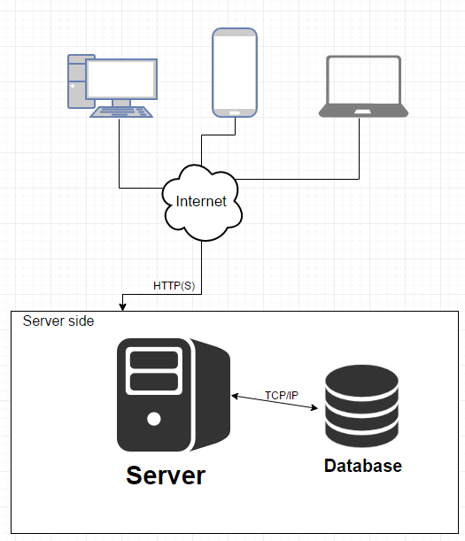

Each user can interact with thin clients running in the browser. Connection between client and server provide by HTTP(S) protocol. Database and server store on the same machine. Connection between database and server provide by TCP/IP.